**SUBGROUP IDENTIFICATION WITH DIFFERENTIAL EFFECT OF CARDIORESPIRATORY FITNESS FOR All-CAUSE AND DISEASE SPECIFIC MORTALITY: SURVIVAL REGRESSION-BASED RECURSIVE PARTITIONING APPROACH**

**Supplementary information**

1. Subgroup based on training data: all-cause mortality

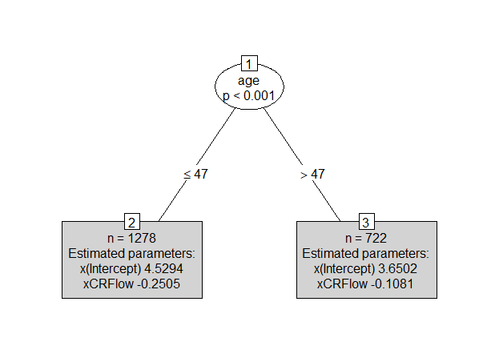

1. Subgroup based on test data: all-cause mortality

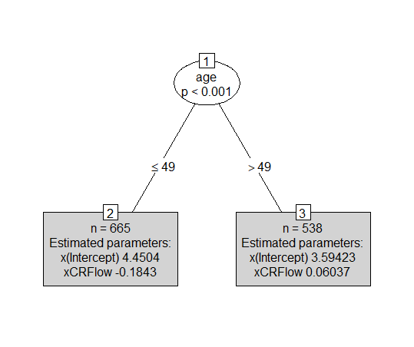

1. Subgroup based on training data: Mortality due to CVD

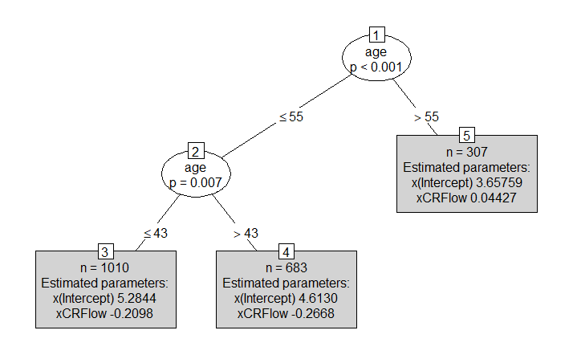

1. Subgroup based on test data: Mortality due to CVD

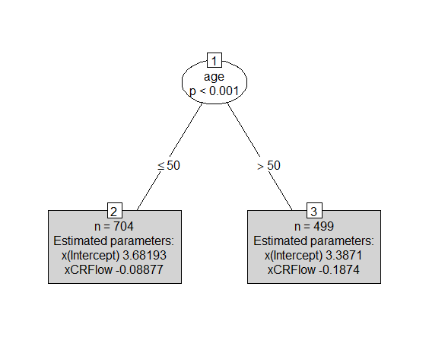

1. Subgroup based on training data: Mortality due to cancer

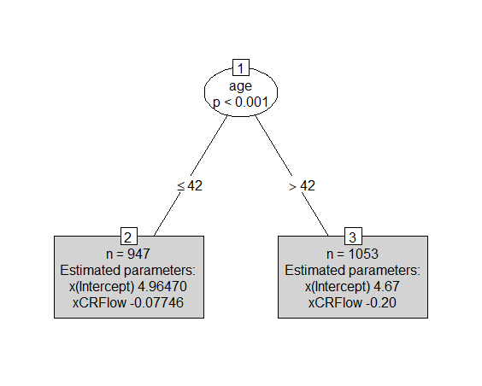

1. Subgroup based on test data: Mortality due to cancer

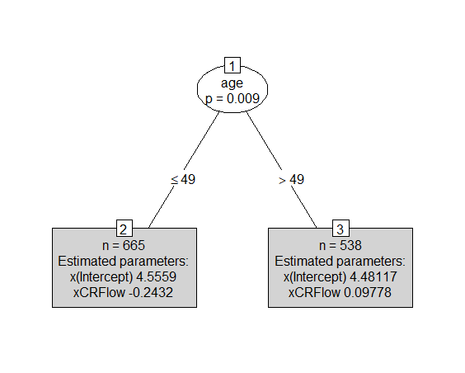

1. Subgroup identification based on VT Classification tree from iteration I for all-cause mortality

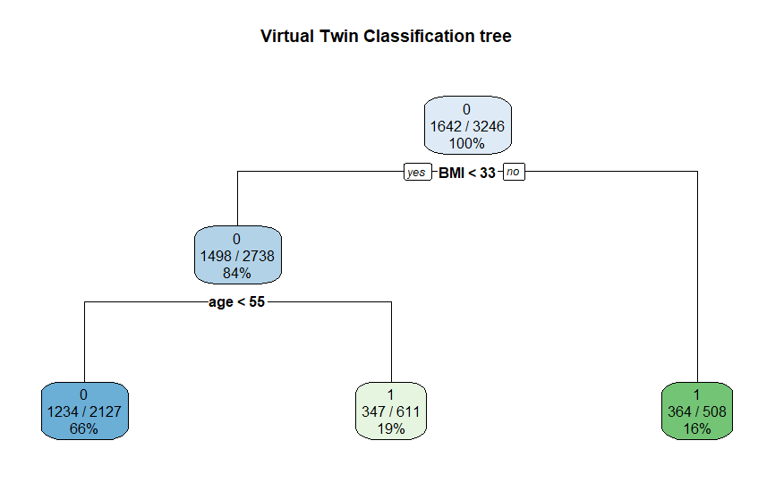

1. Subgroup identification based on VT Classification tree from iteration II for all-cause mortality

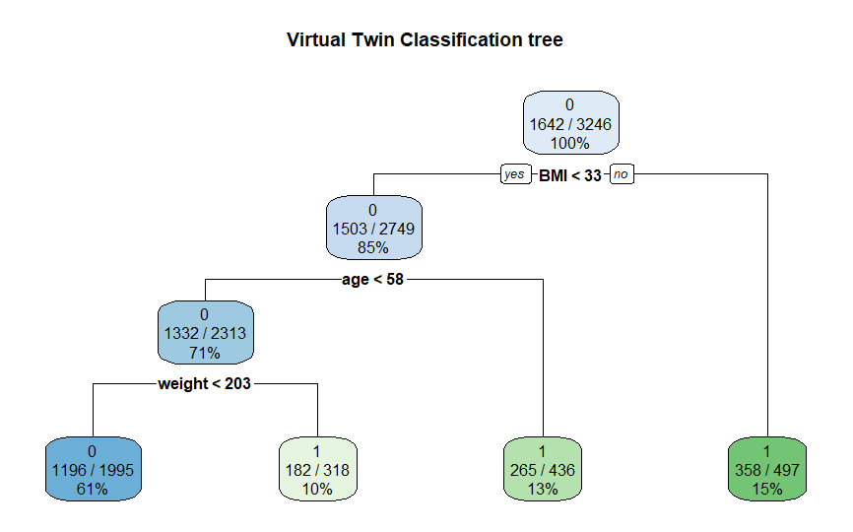

Table 1: Results of multivariate semi-parametric survival regression analysis for mortality under three scenarios

|  |  |  |  |  |  |  |  |  |  |  |  |  |  |  |
| --- | --- | --- | --- | --- | --- | --- | --- | --- | --- | --- | --- | --- | --- | --- |
|  | All cause mortality | | | |  | Mortality due to CVD | | | |  | Mortality due to cancer | | | |
| Covariate | Esti-  mate | H. R | 95% Conf. Int. | | Esti-  mate | H. R | 95% Conf. Int | | Esti-mate | H. R | 95% Conf. Int | |
| CRF (low) | .21* | 1.24 | 1.01 | 1.53 | .170 | 1.19 | 0.82 | 1.72 | .395* | 1.49 | 1.02 | 2.15 |
| Age | .10*** | 1.10 | 1.09 | 1.11 | .102*** | 1.11 | 1.09 | 1.13 | .086*** | 1.09 | 1.07 | 1.11 |
| Sex (Male) | .36*** | 1.44 | 1.19 | 1.85 | .544** | 1.72 | 1.20 | 2.47 | .530** | 1.69 | 1.19 | 2.43 |
| BMI | -.001 | 0.99 | 0.97 | 1.03 | -.009 | 0.99 | 0.94 | 1.04 | -.035 | 0.97 | 0.92 | 1.02 |
| Triglyceride | -.0004 | 0.99 | 0.99 | 1.00 | .001 | 1.00 | 0.99 | 1.00 | .001 | 1.00 | 0.99 | 1.00 |
| Obesity | .023 | 1.02 | 0.78 | 1.34 | -.173 | 0.84 | 0.51 | 1.38 | .137 | 1.15 | 0.70 | 1.87 |
| Glucose | .004*.* | 1.00 | 0.99 | 1.01 | .004 | 1.00 | 0.99 | 1.01 | -.006 | 0.99 | 0.98 | 1.01 |
| Cholesterol | .002 | 1.00 | 0.99 | 1.00 | .002 | 1.00 | 0.99 | 1.01 | -.001 | 0.99 | 0.99 | 1.00 |
| Dyslipidemia | -.096 | 0.91 | 0.75 | 1.09 | .196 | 0.82 | 0.59 | 1.15 | .007 | 1.01 | 0.71 | 1.42 |
| Hypertension | .28** | 1.32 | 1.09 | 1.60 | .608*** | 1.84 | 1.31 | 2.57 | -.109 | 0.89 | 0.63 | 1.28 |
| Inactivity | .004 | 1.00 | 0.81 | 1.24 | -.135 | 0.87 | 0.60 | 1.26 | -.137 | 0.87 | 0.60 | 1.27 |
| Smoking | .60*** | 1.82 | 1.48 | 2.33 | .707*** | 2.03 | 1.37 | 3.00 | .457* | 1.58 | 1.05 | 2.38 |
| Diabetes | .02 | 1.02 | 0.65 | 1.58 | .300 | 1.35 | 0.65 | 2.79 | -.122 | 0.89 | 0.34 | 2.34 |